7.1.1 Gender Equity

 | 2015 | Workshop and Hands on training under the Spoken Tutorial IIT Mumbai through NMEICT, MHRD being run since 2013 in the institution. | 06th July 2015 | 70 | Computer Science | 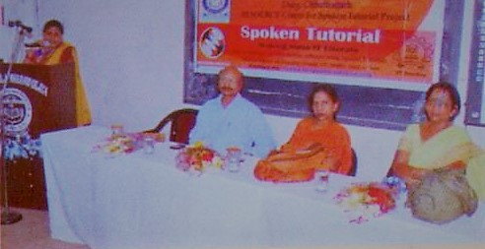
 | 2015 | A lecture organised by Liones Club Bhilai delivered by Senior Physician Bhilai Steel Plant Dr. T.K.Pandy on the Topic ‘Deficiency of Vitamin D and its effects on young Girls’. | 04th August 2015 | 150 | IQAC | 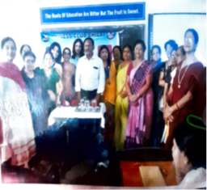
 | 2015 | Lecture on 'Women Empowerment' | 14th May 2015 | 40 | B.Ed | 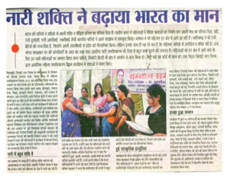
 | 2015 | A Lecture by Vinay Kumar Singh of Tejas IAS Academy titled 'Job Opportunities in Govt & Public Sectors'. | 21-Sep-15 | 80 | IQAC | 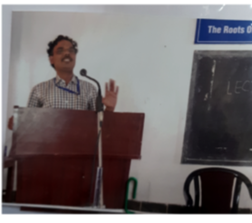
 | 2015 | Workshop on - 'Cyber Crime, Cyber Law & its Social Impact' by Mr.I Khan, President Shild Sewa Samithi and Ms. Geetika. | 10th October 2015 |  | Computer Science | 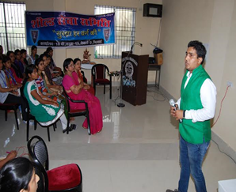
 | 2015 | A lecture on Mock Test and Mock GD/PI by Mr.Sanjay Ashtkar of IBS Business School. Hyderabad | 13th October 2015 | 70 | IQAC | 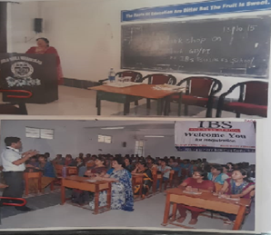
 | 2016 | Lecture by Dr. Tapas Mukherjee HOD Bhilai III College entitled 'Communication Skills in English' for the Part III students of all Faculties. | 22nd February 2016 | 80 | English | 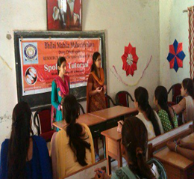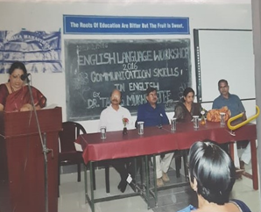
 | 2016 | Workshop and Hands on Training under the Spoken Tutorial IIT Mumbai through NMEICT, MHRD being run since 2013 in the institution. | 21st August 2016 | 84 | Computer Science | 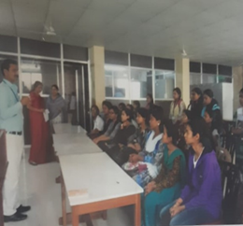
 | 2016 | ‘ Naari Samman Mera Abhiman’ a Signature campaign by Jansunwai Foundation for any kind of support to girls whenever in crisis or problem. | 3rd November 2016 | 150 | IQAC
 | 2016 | NSS students trained the public on ' Cashless Transaction' | 28th December 2016 | 90 | NSS
 | 2017 | Traffic Awareness Rally' from the College to Hudco and back. | 15th January 2017 | 40 | NSS
 | 2017 | 22 students visited BIT college Durg to attend a lecture delivered by Collector Durg IAS R.Sangeeta on 03.02.2017 on 'How to prepare for and face UPSC Exam'. | 3rd February 2017 | 22 | IQAC | 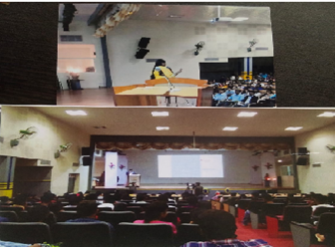
 | 2017 | 11 days 'Personality Development & Communication Skills' classes by Nitin Kumar Pharsankhanewale a Management passout from BITS Pllani for PGDCA students. | 22nd February 2017 |  | IQAC
 | 2017 | 11 days 'Personality Development & Communication Skills' classes by Nitin Kumar Pharsankhanewale a Management pass out from BITS Pllani for M.com IV sem students. | 23rd February 2017 |  | IQAC
 | 2017 | Lecture on 'Women Safety' by TI Mrs. Navi Monika Pandey | 1st September 2017 | 150 | NSS
 | 2017 | 3 days 'Entrepreneurship Awareness Camp' sponsored by DST, Government of India New Delhi and CITCON Raipur. | 18th September 2017 | 75 | IQAC | 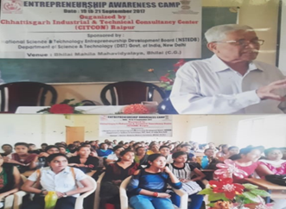
 | 2017 | Career Guidance Session by Dr. Aruna Killaru of East Tennise state University USA on the topic ‘Scientific Pursuit & Beyond’ | 22nd November 2017 | 60 | IQAC | 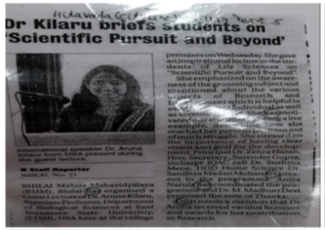
 | 2017 | To Make Human Chain to aware in vote. Human chain formed to convey the importance of voting. | 16th April 2018 | 50 | B.Ed | 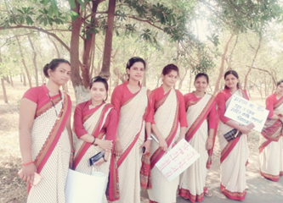
 | 2018 | Lecture by Dr.Nisreen Husain, HOD Zoology, Govt. Dr.WW Patankar Girls PG college, Durg, cg on 'Career Opportunities and Entrepreneurship Prospects in Biology'. | 12th July 2018 | 69 | Botany | 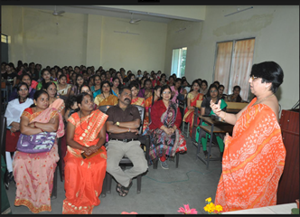
 | 2018 | B. Ed. students visited Old Age Home, Durg and shared some happy moments with them. | 15th August 2018 | 24 | B. Ed. | 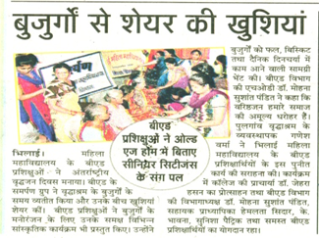
 | 2018 | Seminar on Career Guidance titled 'What to do after graduation' by ACME Academy | 24th October 2018 | 32 | Computer Science | 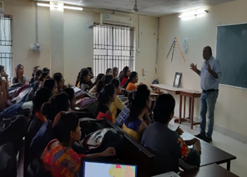
 | 2018 | Guest Lecture on Laughter Therapy against Stress | 21st November 2018 | 55 | B. Ed. | 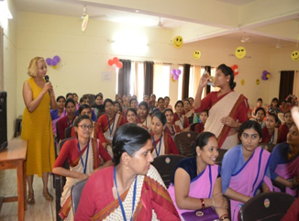
 | 2019 | Motivational Lecture Mr.Sunil Kumar Thawani of Dubai on Managing Quality Life through Concentration | 1st January 2019 | 50 | IQAC | 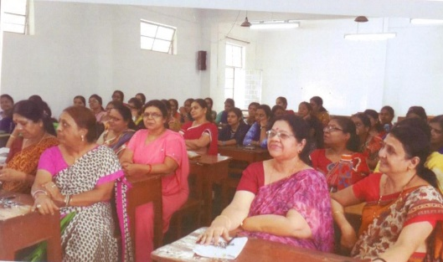
 | 2019 | 10 days’ Workshop on 'Career Awareness & Pre Placement Training' by Mr. Vikas Singh of Impact Training Services, Bhilai | 16th January 2019 | 51 | Computer Science | 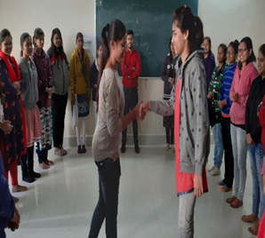
 | 2019 | Awareness regarding voting | 18th April 2019 | 70 | B. Ed. | 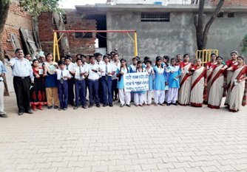
 | 2019 | Workshop on 'Youth Empowerment' by team society N.G.O. Dr Md. Buheji from U.A.E, founder of International Institute of Inspiring Project was the main speaker. | 06th December 2019 | 80 | IQAC | 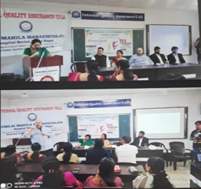
 | 2019 | Lecture on 'Reading Skills'by Dr.C.S.Sharma Associate Prof CSIT Durg for students of Part III classes. | 17th December 2019 | 50 | English | 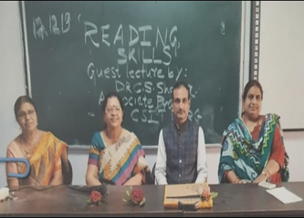
 | 2020 | Lecture on 'Corporate Expectations’ by Mr.Nikhil Naynani of PIBM Pune for Part III students. | 18th January 2020 | 98 | English | 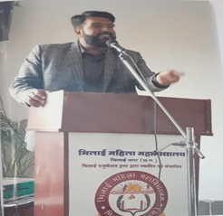
 | 2020 | Webinar on 'Impact of Pandemic Covid-19 on Women Worldwide’ | 1st July 2020 | 140 | IQAC | 