3.1.1 Grants received from Government and non-governmental agencies for research projects / endowments in the institution during the last five years (INR in Lakhs)

3.1.1.1: Total Grants from Government and non-governmental agencies for research projects / endowments in the institution during the last five years (INR in Lakhs)

Name of the Department
Commerce | 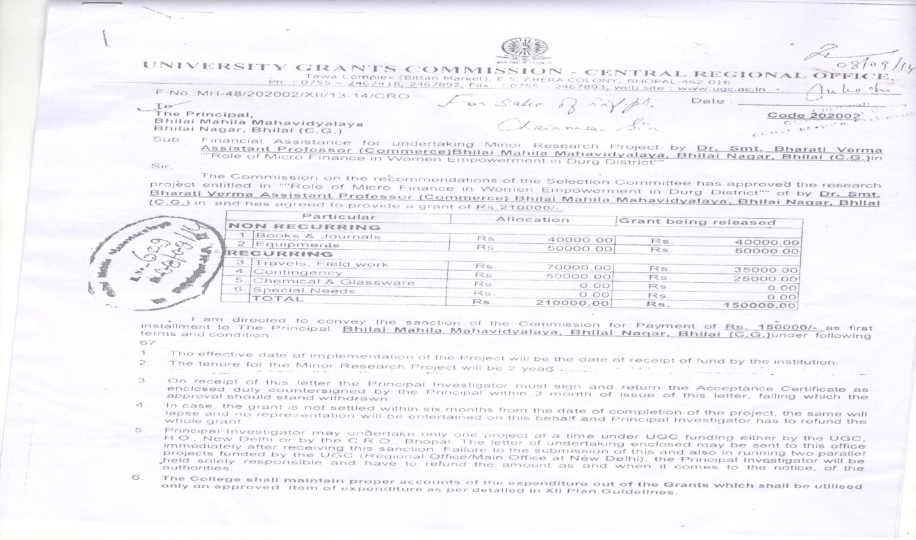
Commerce 2014-2015 | 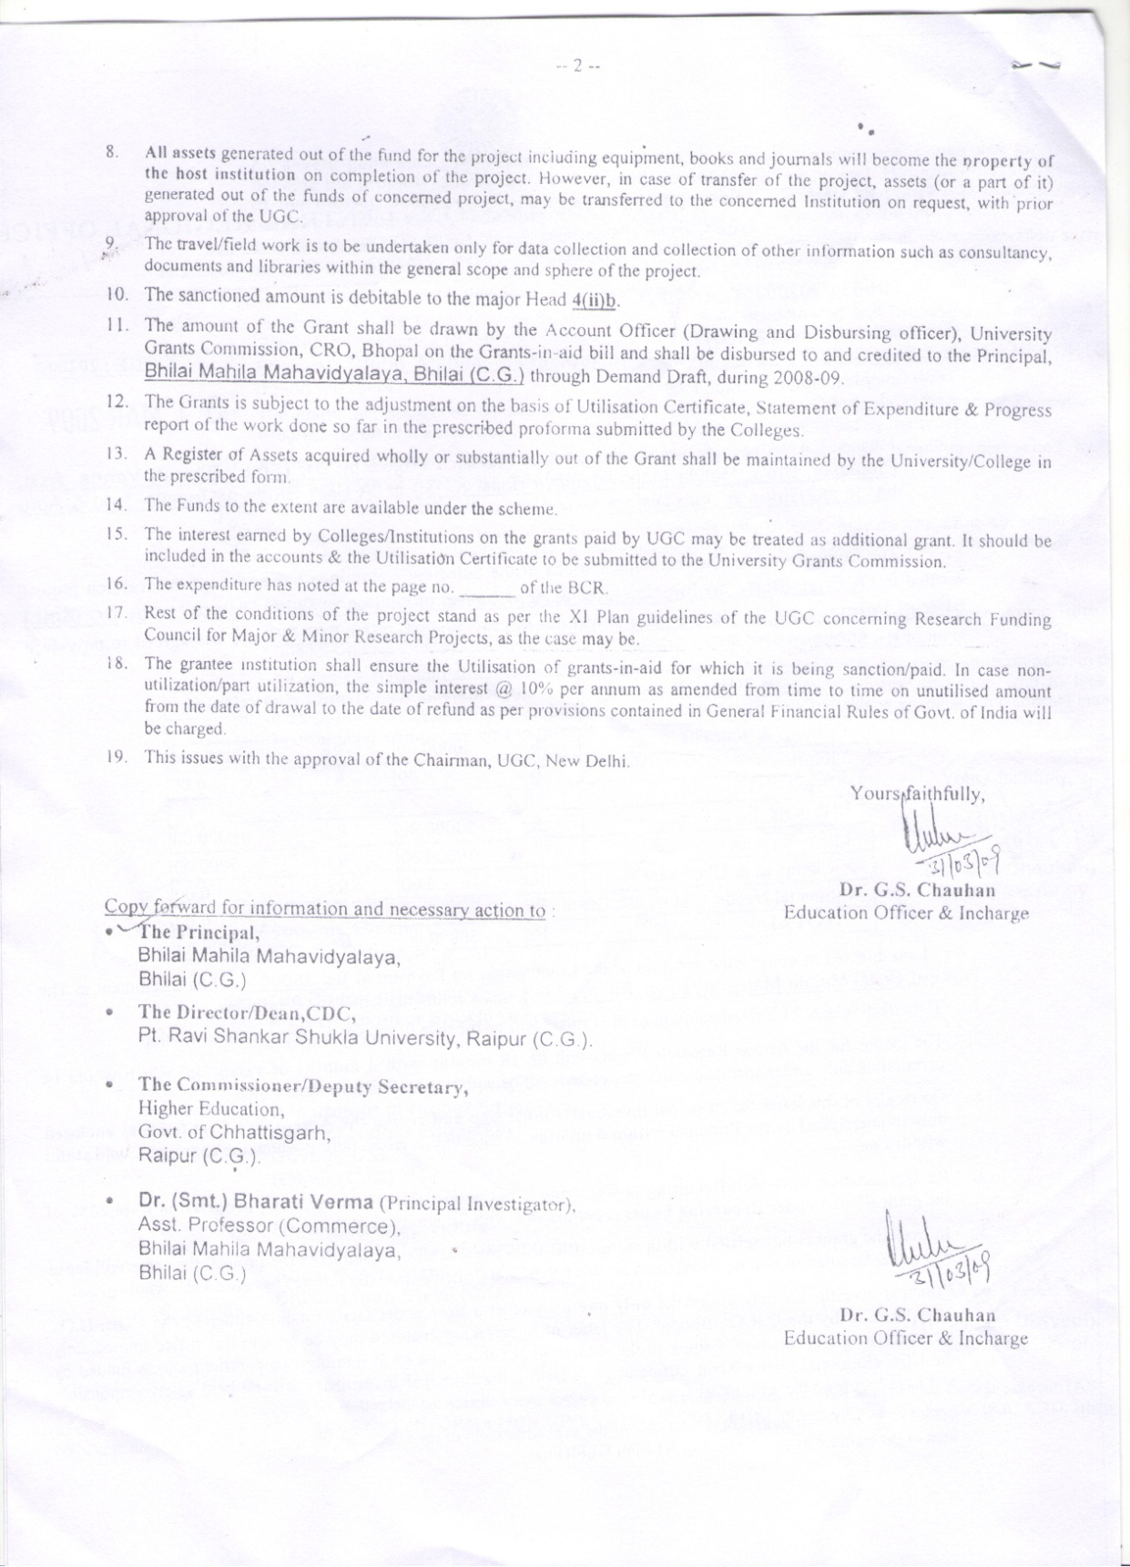
 | 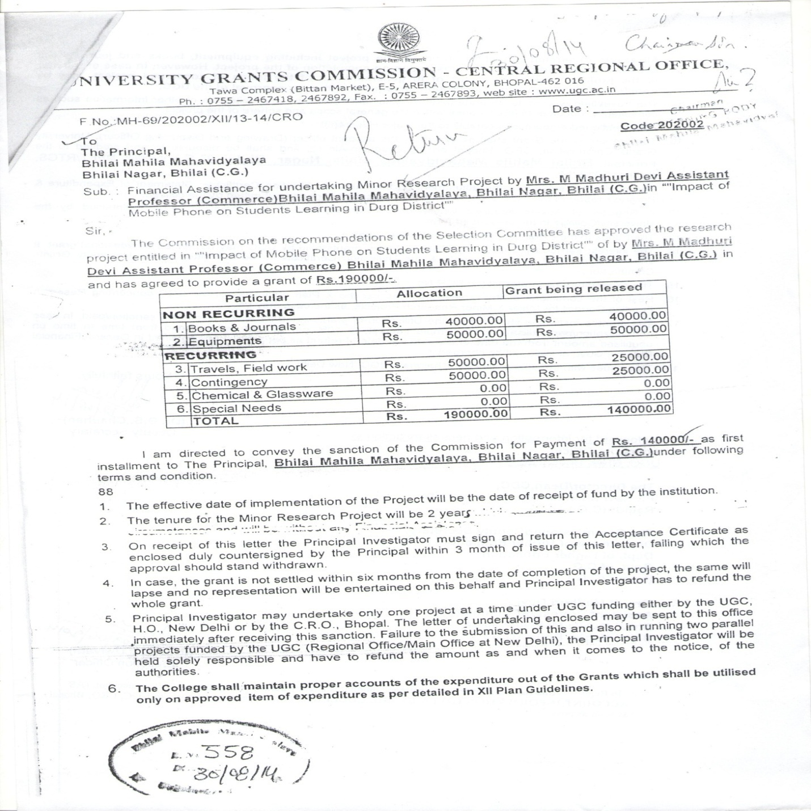
 | 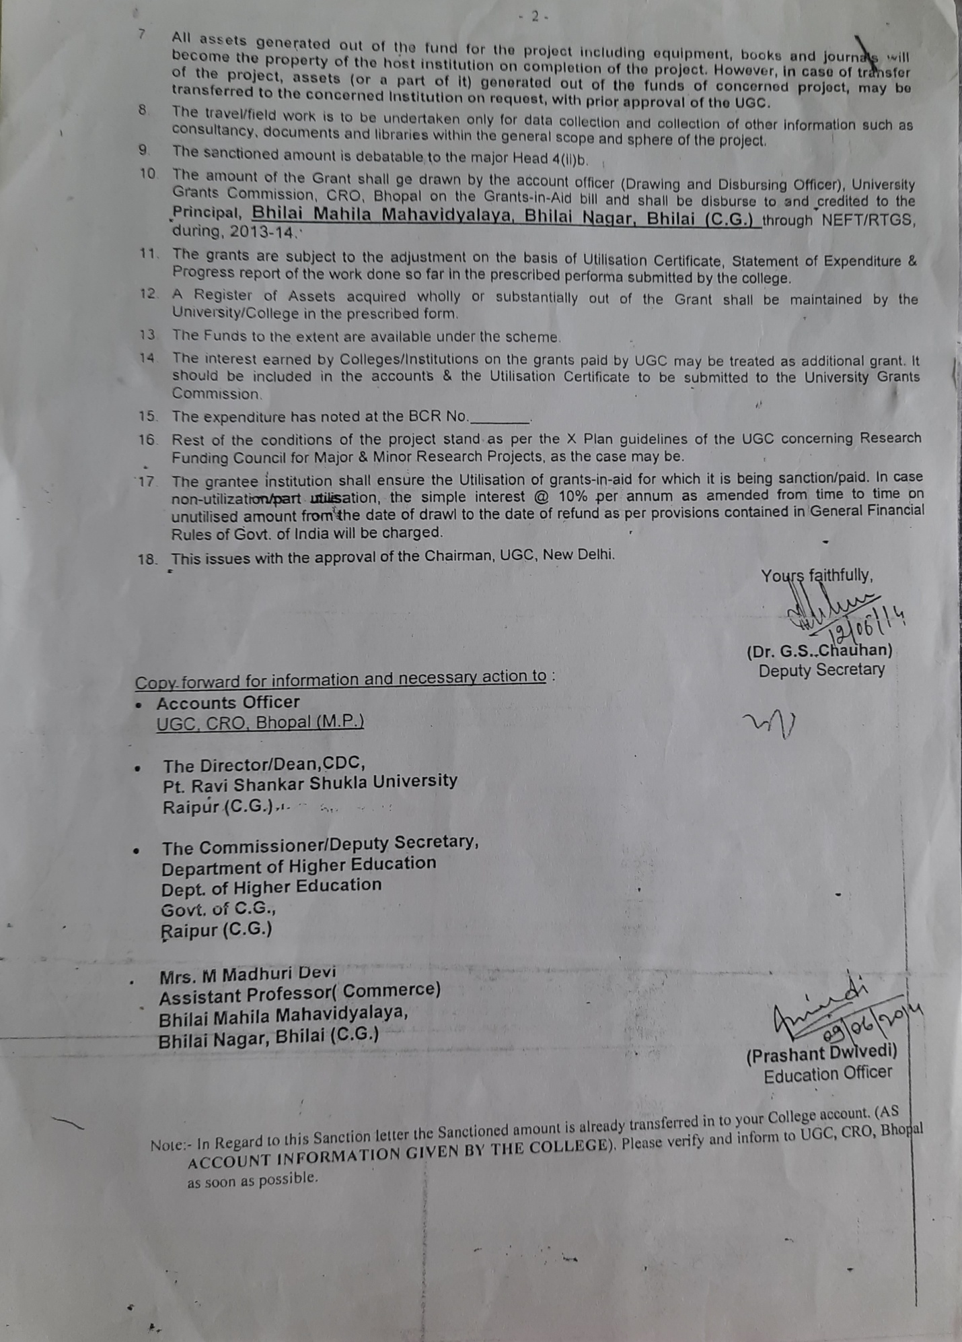
 | 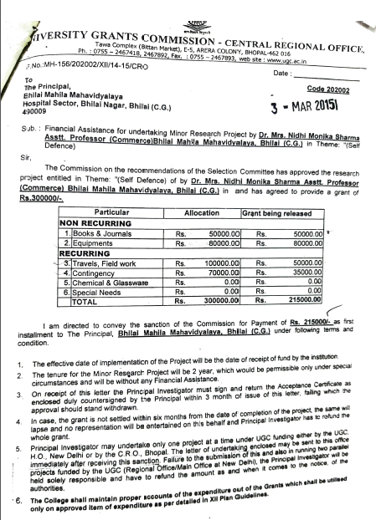
 | 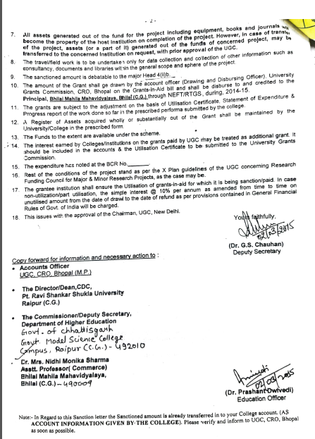
Botany | 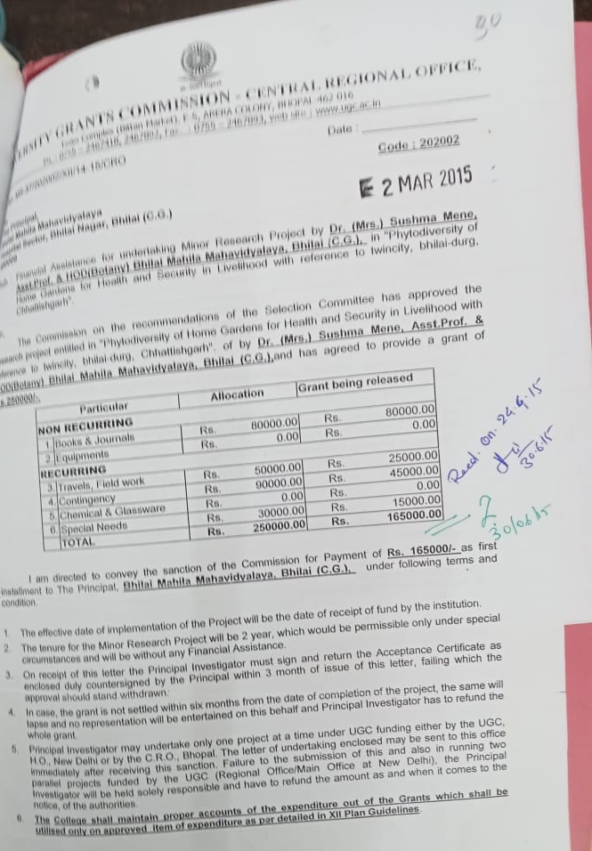
 | 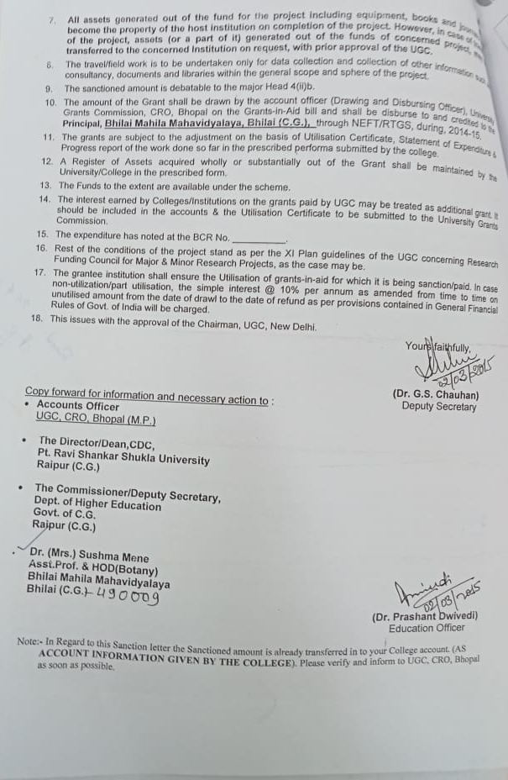
 | 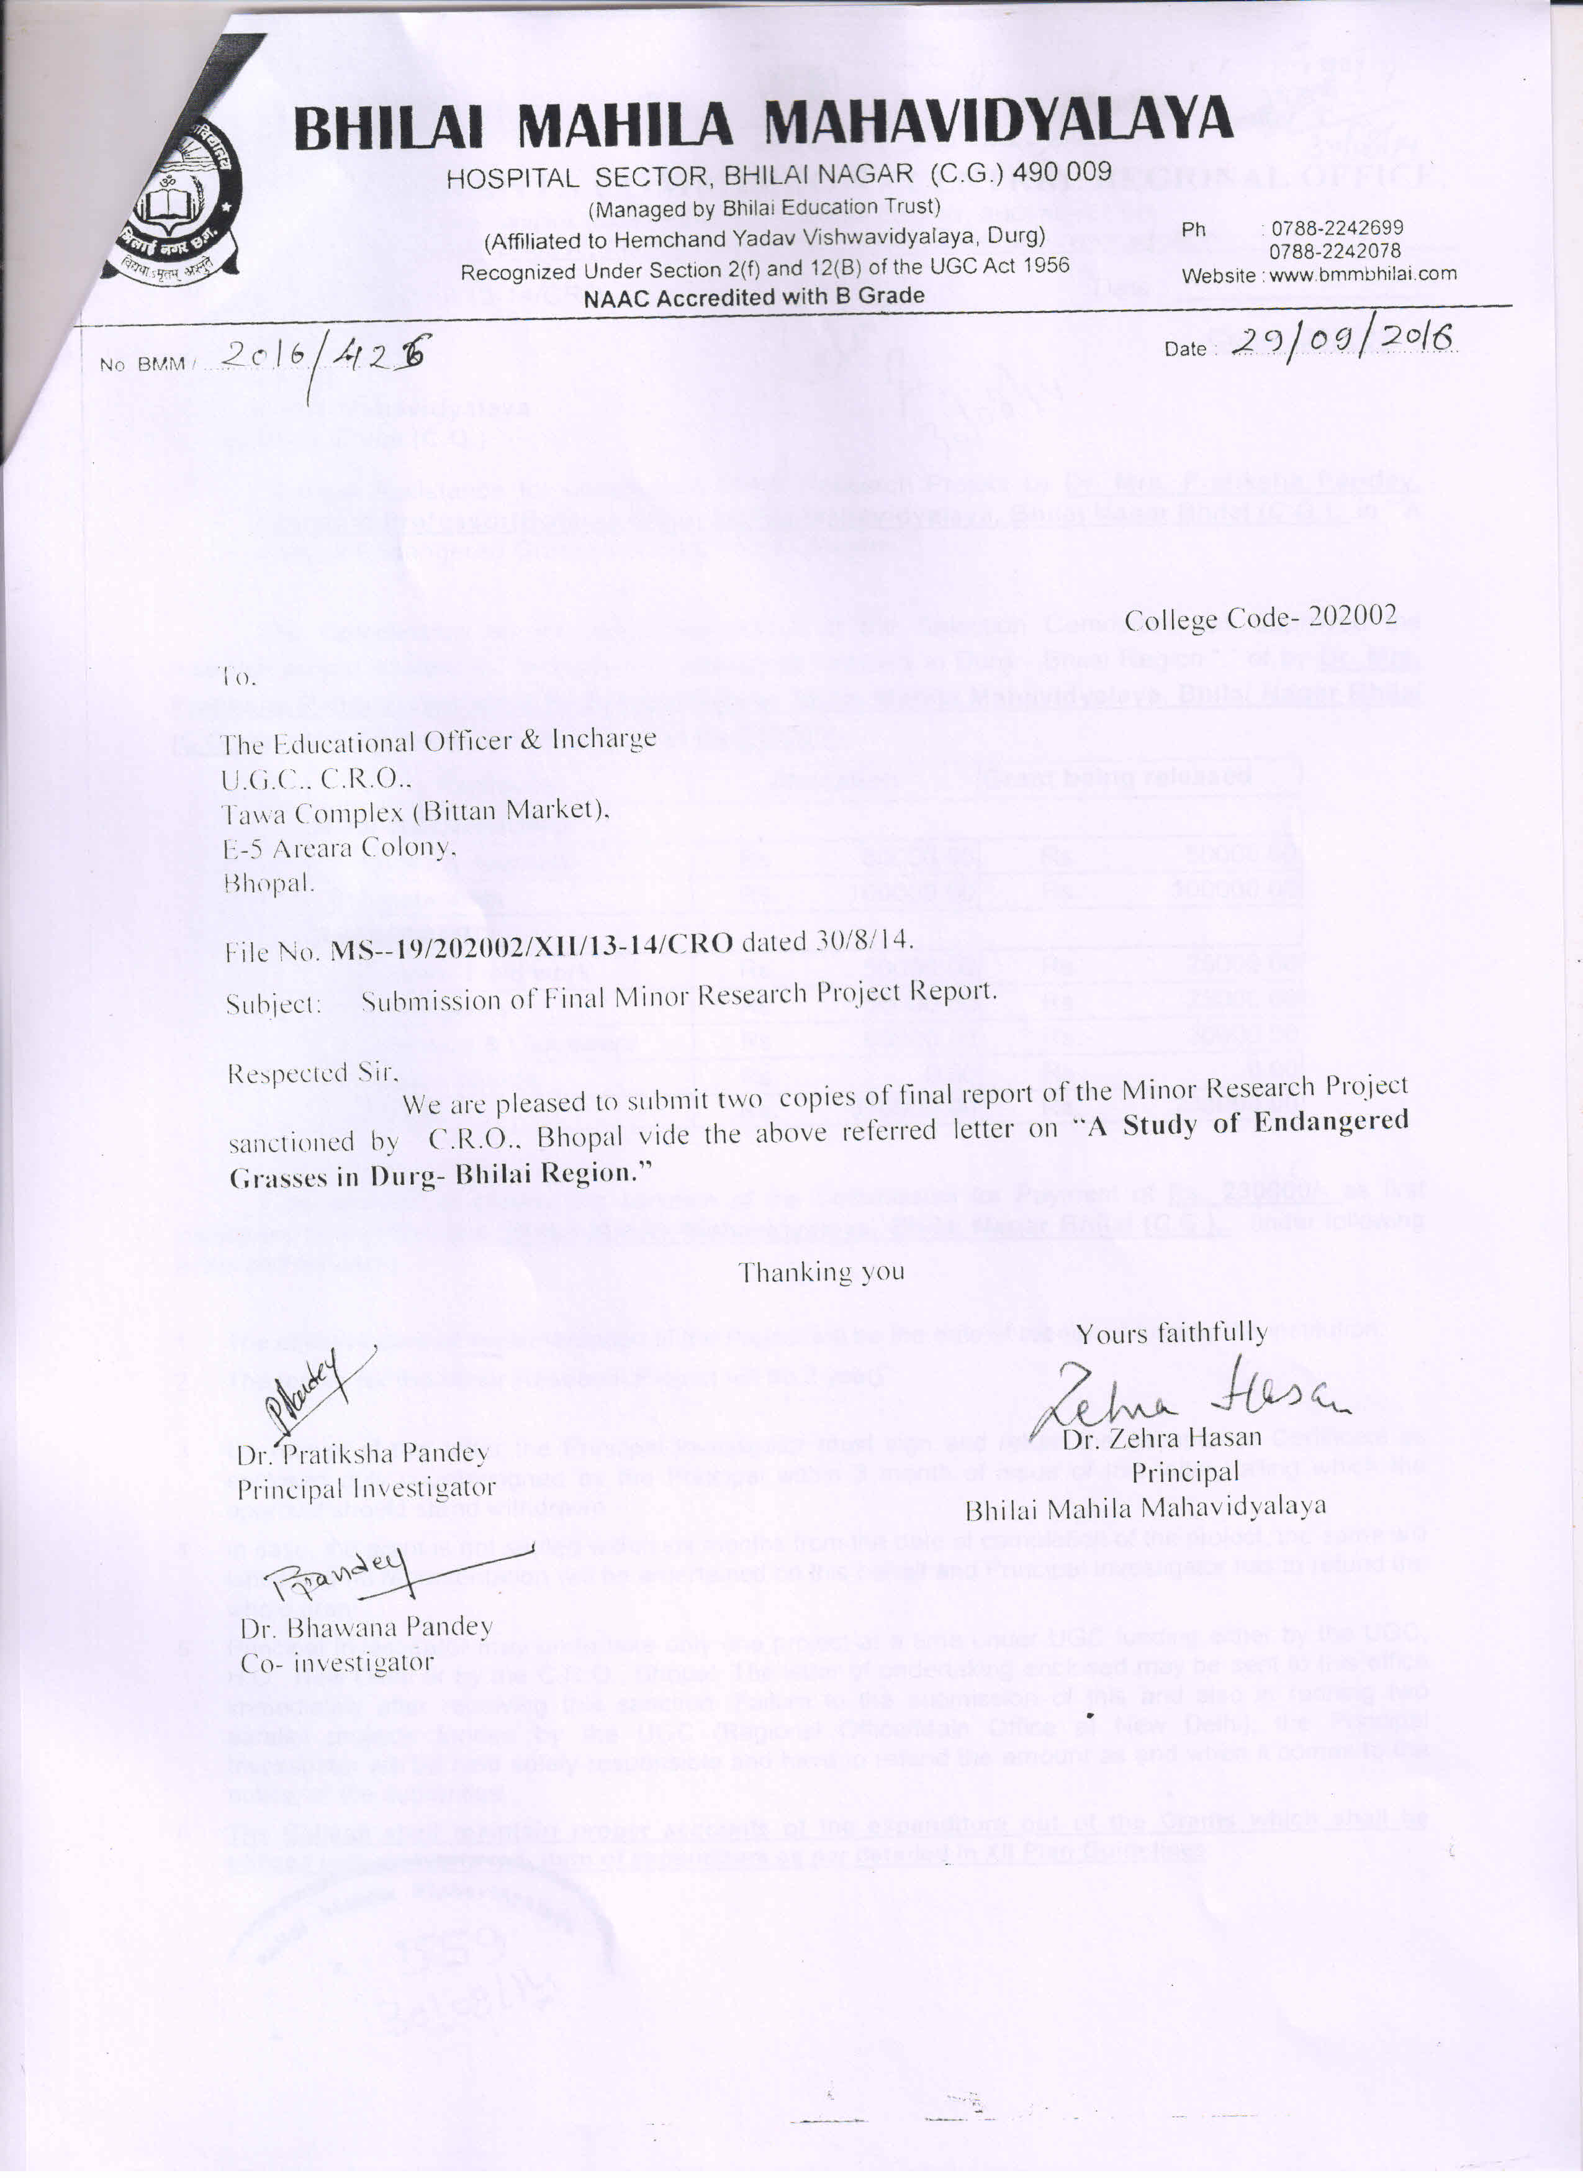
Zoology | 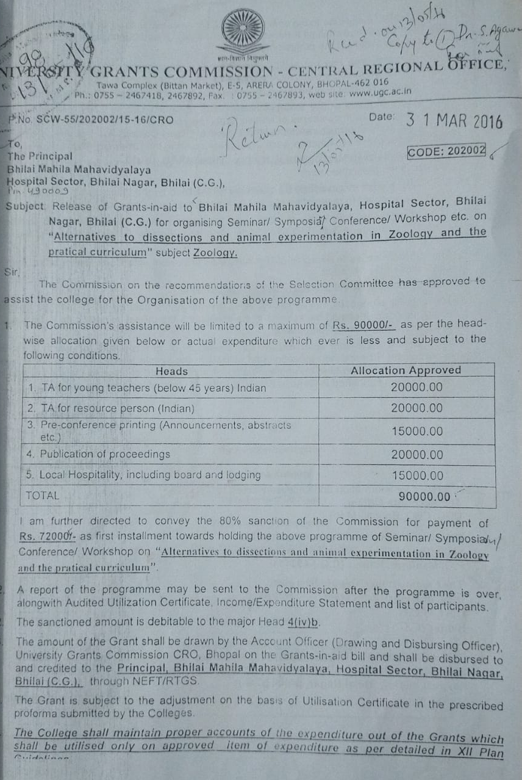
Physics | 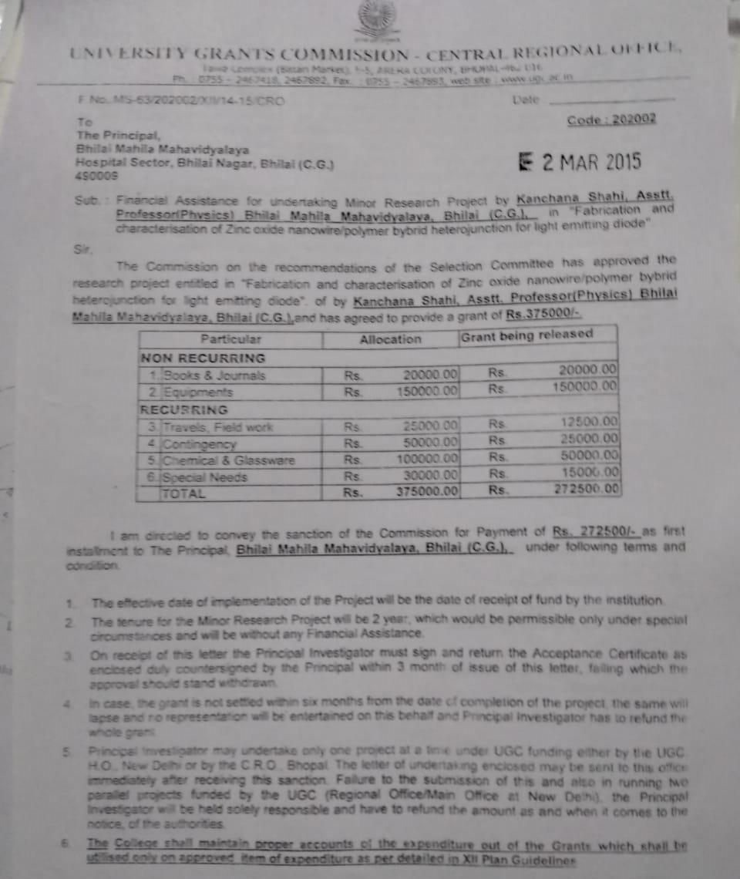
Biotechnology | 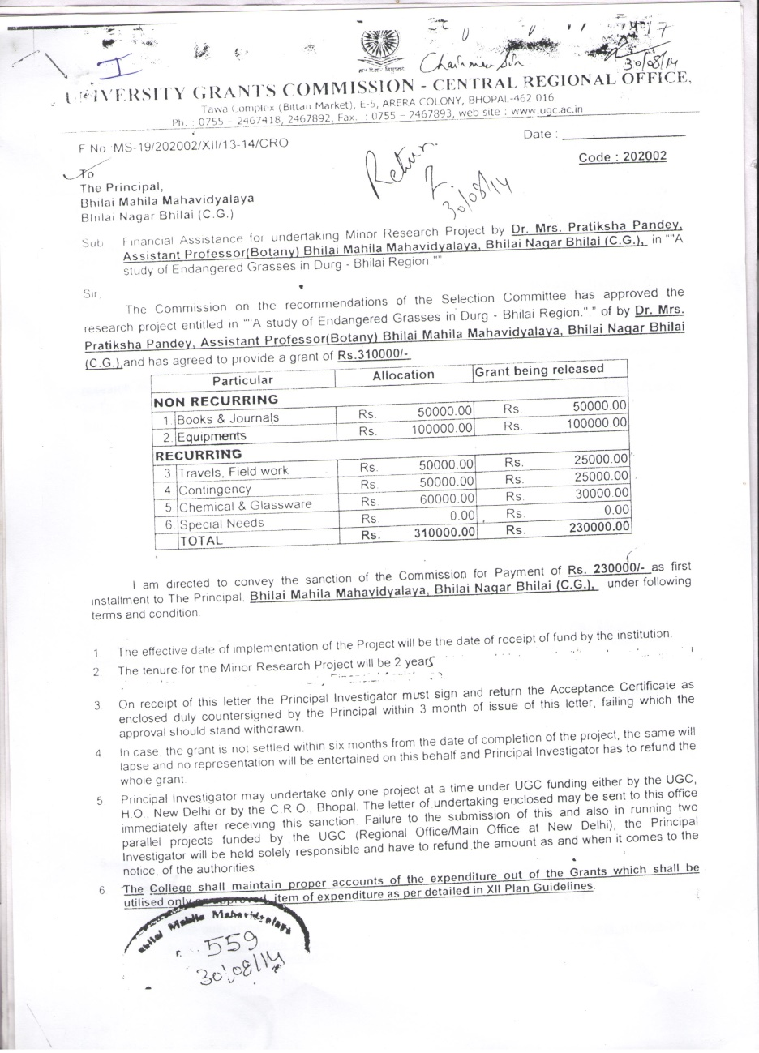
 | 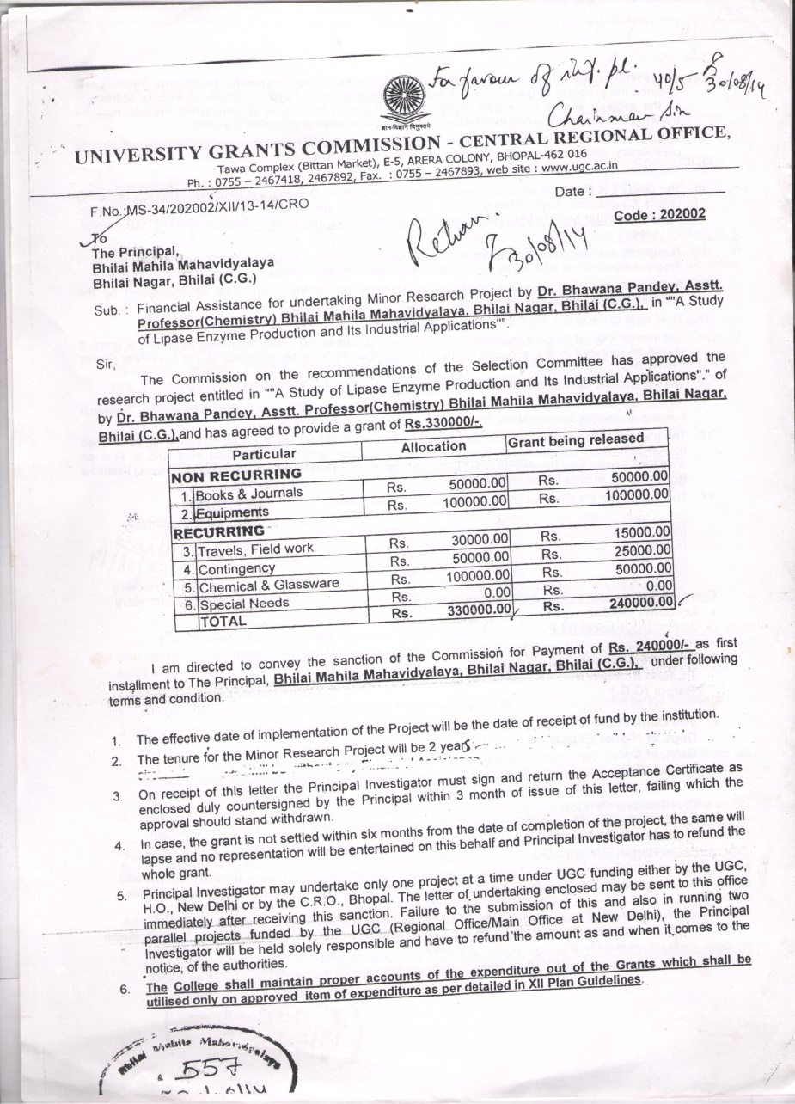
 | 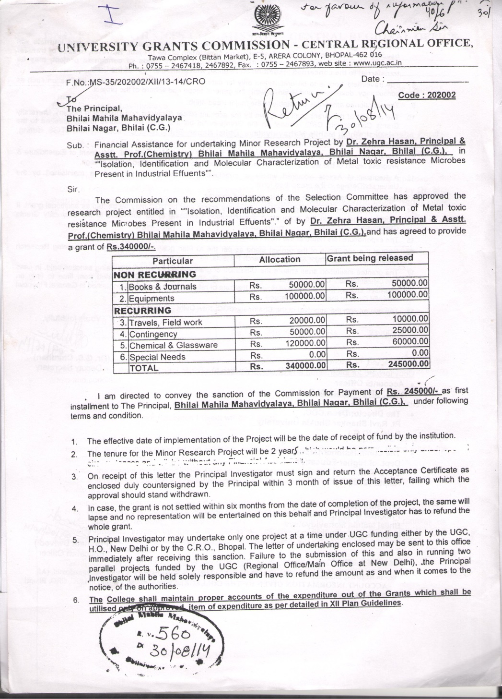
 | 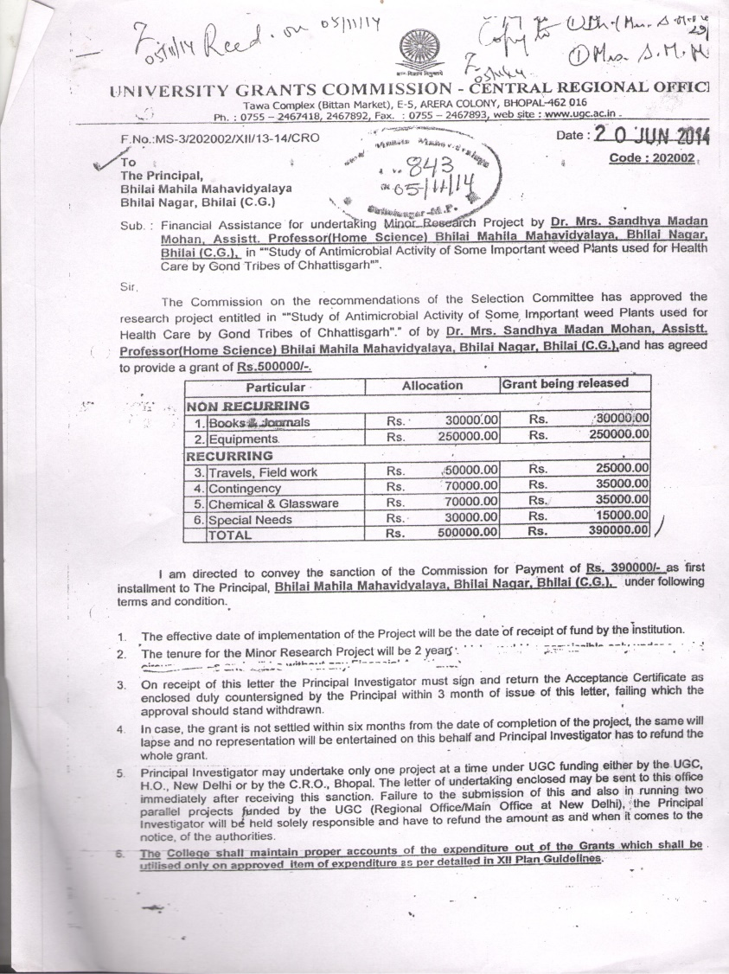
 | 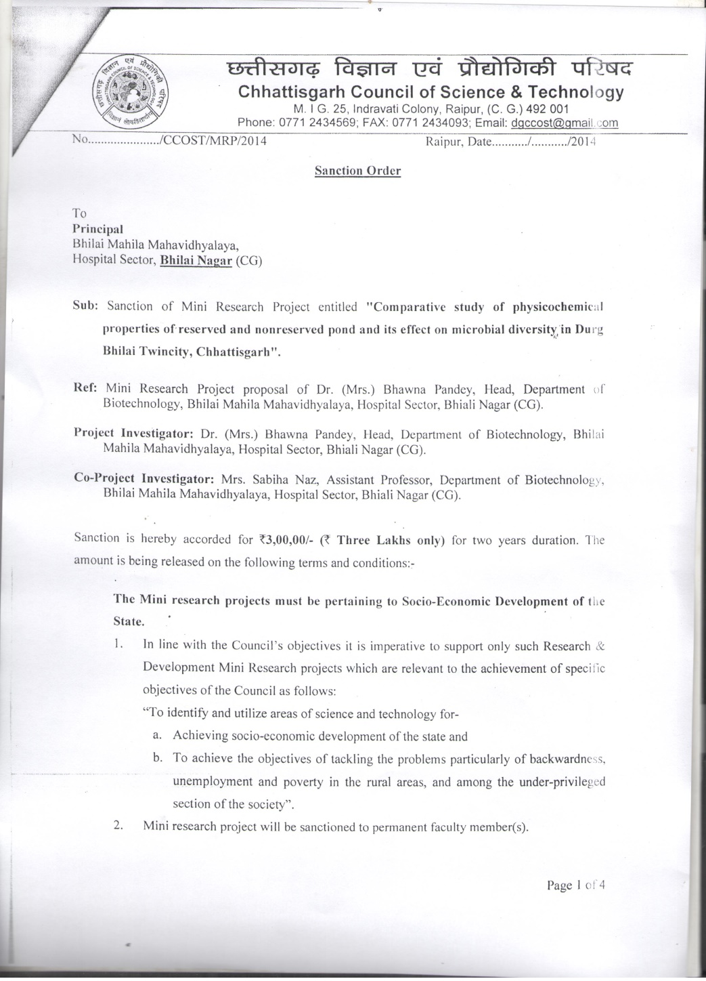
B.Ed.
Hindi

