3.4.2 Number of awards and recognitions received for extension activities from government/ government recognized bodies during the year 2021-22.

Sl.no | Teacher | Competition | Position
1. | Dr.Bhawana Pandey | External review Commitee | National Level
2. | Dr.Bhawana Pandey | State  Co-ordinator | Human Welfare and Social Development Organization Chhattisgarh | 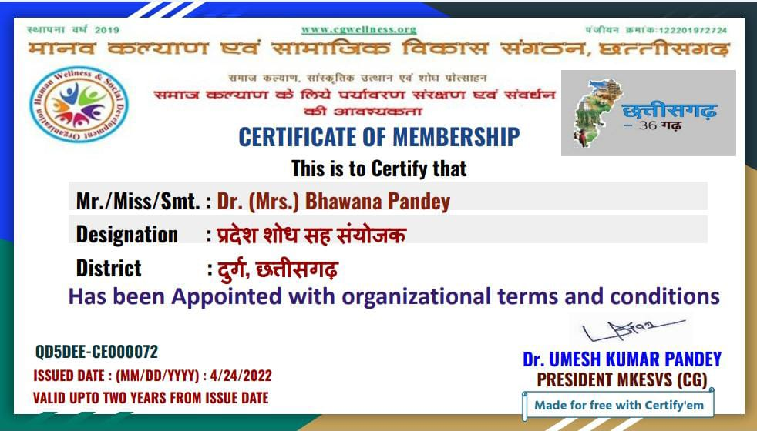
3 | Dr. Deepti Chauhan | Pashu pakshi bachao abhiyan | 2nd | 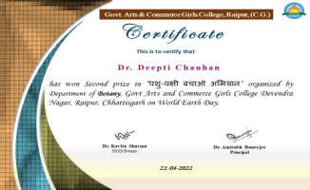
4 | Dr. M. Madhuri Devi | Indian Researcher Award | National Level | 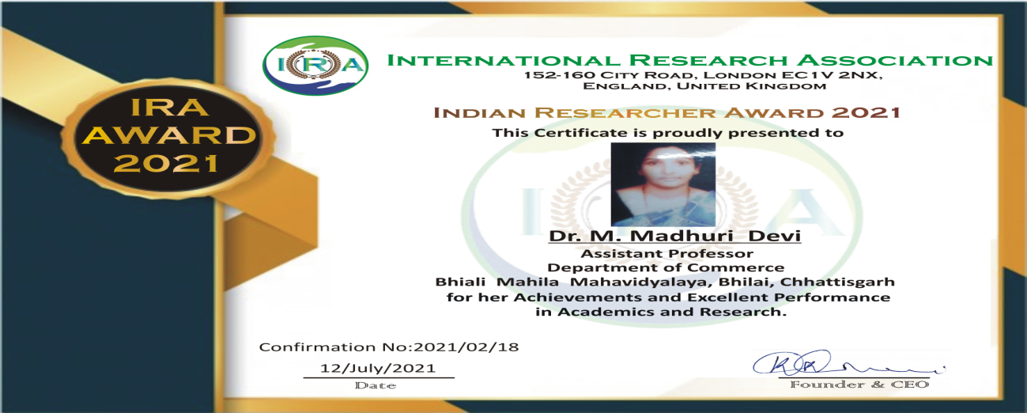
5 | Dr. M. Madhuri Devi | Adarsh Vidya Saraswati Award | National Level | 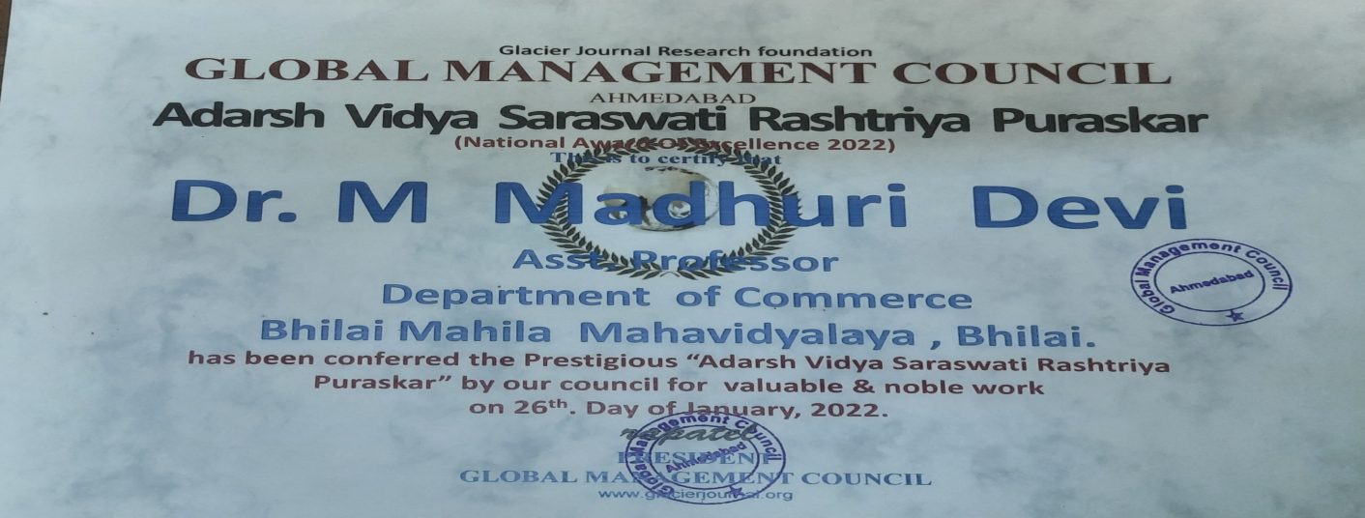
6 | Dr. M. Madhuri Devi | Best Teacher Award | National Level | 