3.4.3 Number of extension and outreach Programmes conducted by the institution through NSS/ NCC/ Red Cross/ YRC etc., (including the programmes such as Swachh Bharat, AIDS awareness, Gender issues etc. ) and/or those organized in collaboration with industry, community and NGOs during the year

3.4.4. Number of students participating in extension activities at 3.4.3.

S.N. | ACTIVITY | DATE | FEEDBACK | PROFF
1 | Poster On Word Environment Day | 5/6/2021 | 30 volunteer Participate and aware People Through Social Media | 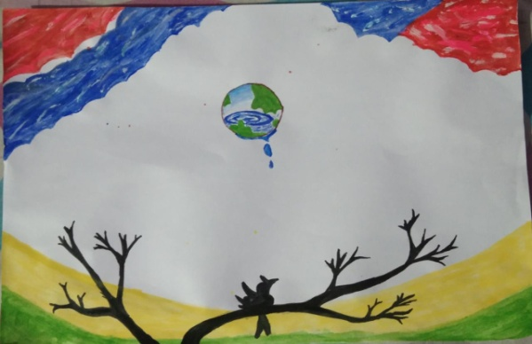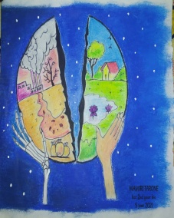
2 | Tree plantation | 9/6/21 | 20 volunteer Planted plants in BMM campus | 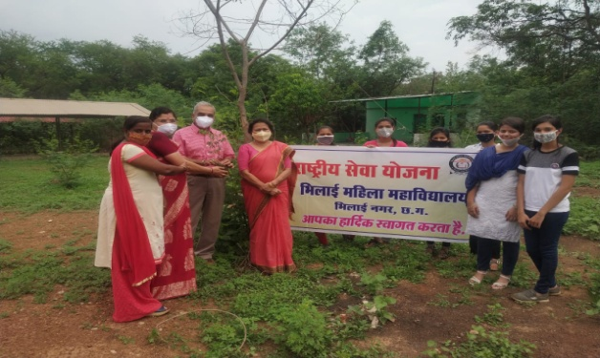
3 | Yoga Day | 21/6/21 | 23 volunteer participate in Online yoga day which is conduct by Hemchand Yadav university | 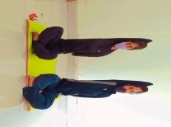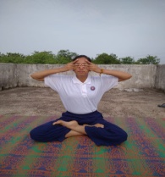
4 | Tree plantation | 5/7/21 | Guest Vijay Baghel planted fruit plant in college campus 35 volunteer participate | 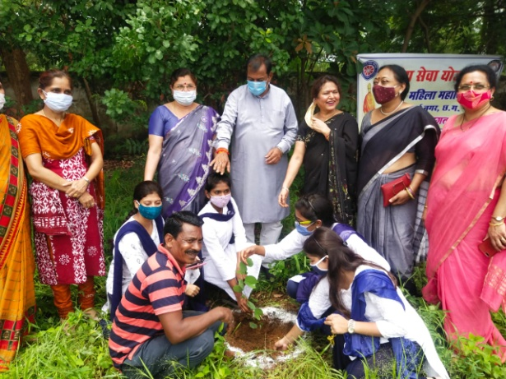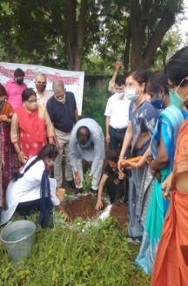
5 | Tree plantation | 9/7/21 | SSB and 20 NSS volunteer planted tree in sector 2 bhilai vidyalaya ground | 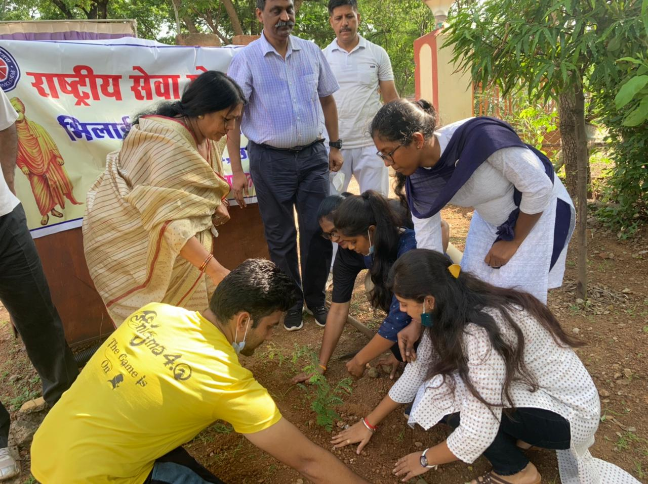
6 | Tree plantation | 18/7/21 | SSB and 32 NSS volunteer planted tree CGST Bhawan 32 Bangla | 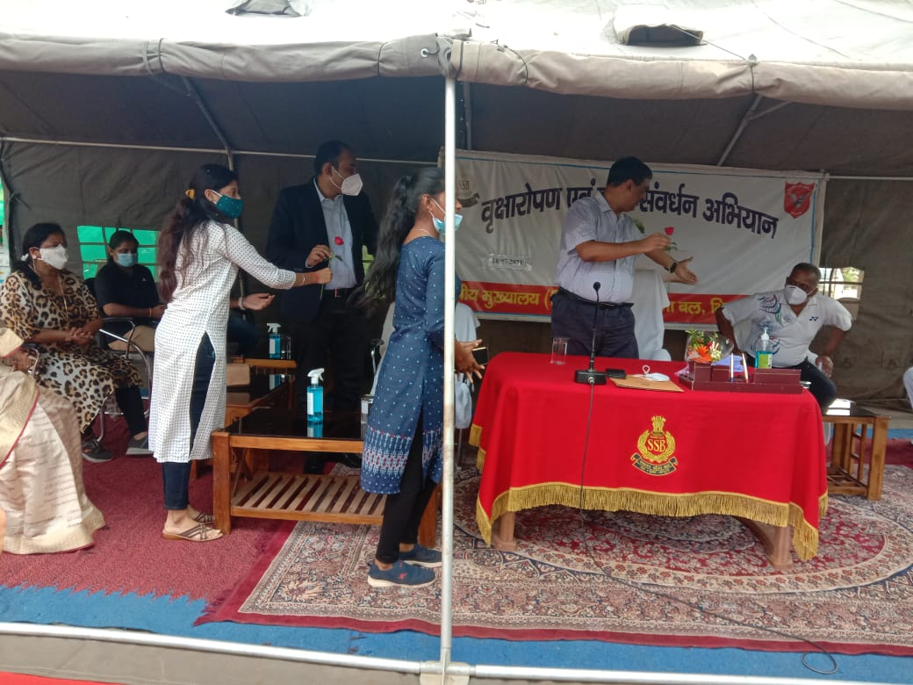
 | Tree plantation | 25/7/22 | NSS volunteer planted tree in Sector 8 park in presence principal Dr Sandhya Madan Mohan and SSB IG | 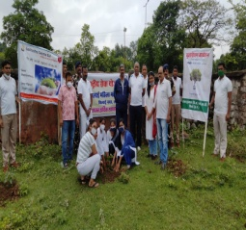
7 | Swacchhta Program | 1/8/21 | Swacchhata pakhwada programme celebrated 1 to 15 August all volunteer take oath that they clean our environment | 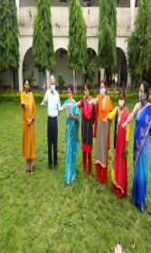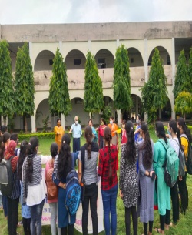
8 | Online workshop on time bank | 2/8/21 | 62 NSS volunteer download the app and help the senior citizen | 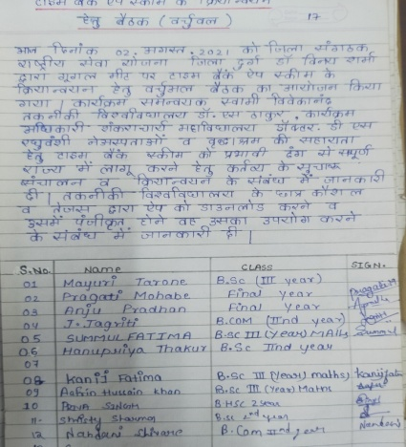
9 | Swacchhta Program | 3/8/21 | 42 volunteer take oath on this occasion
10 | Swacchhta Program | 5/8/21 | Swacchhata pakhwada programme done in college campus nss volunteer clecn the veranda of college | 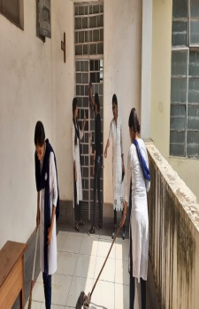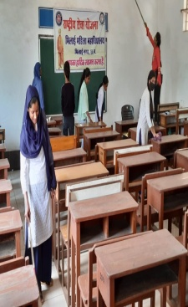
11 | Swacchhta Program | 14/8/21 | Swacchhata pakhwada programme done in manva sewa parisar bhilai | 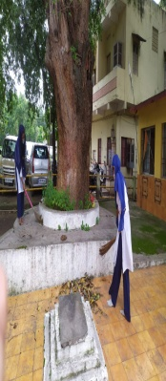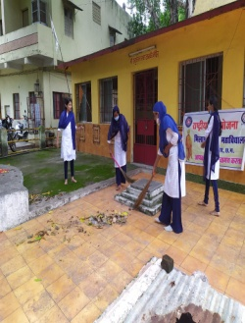
12 | Poster Competation | 19/8/21 | Rakth dan maha dan is the topic of the comptation &30volunteerparticipate in this event | 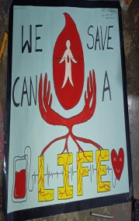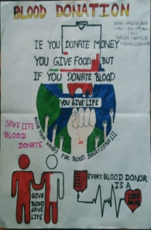
13 | Azadi ka amrit mohatsava | 18/9/21 | Bharat sarkar yuva karyakram and khel mantralaya new Delhi ,BHOPAL and higher Education Raipur organised Fit India Freedom Run2.0 sardar Patel chowk to surana college | 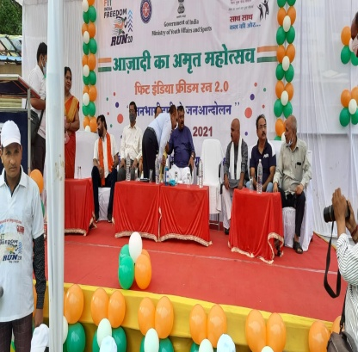
14 | Vaccine programe | 18/9/21 | NSS volunteer help in vaccination centre sector 7 | 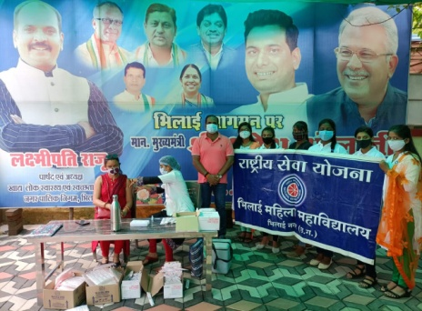
15 | NSS foundation Day | 24/09/21 | Volunteer participate and light on the life of vivakanand and qrganized quies comptation | 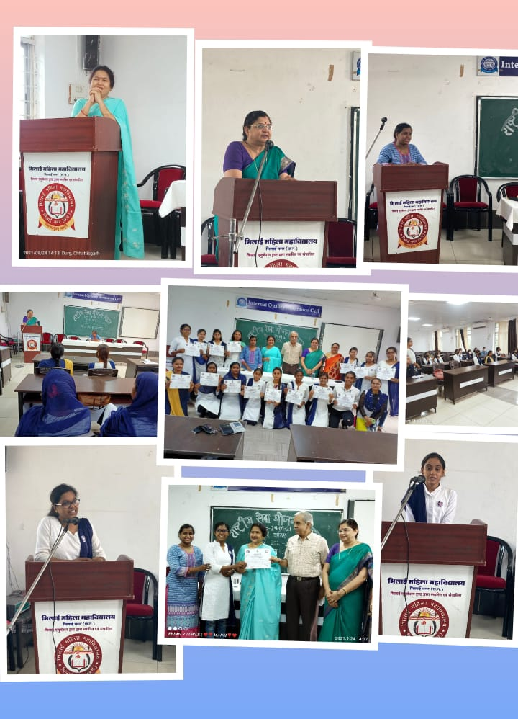
16 | SWIP Campus Ambuster | 1/10/21 | NSS volunteer Mayuri Tarone B.ScIII and Nomisha B.Com. III selected as campus ambassador | 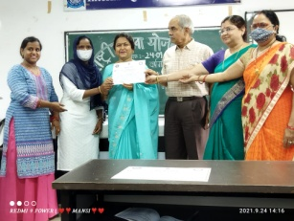
17 | Gandhi Jayanti | 2/10/21 | Volunteer celebrate Gandhi jayanti they take oath to clean the society and awair public don’t use plastic. | 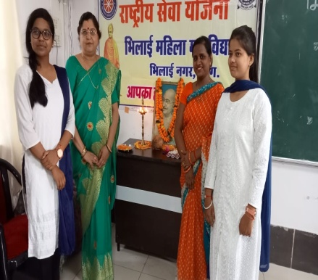
18 | Azadi ka amrit mohatsava | 25/10/21 | Azadi ka amrit mohatsava programme done in manokameshwar Shiv mandir campus nss volunteer clean the campus of mandir . | 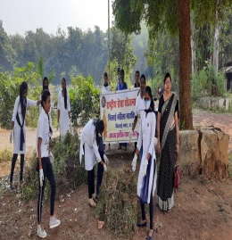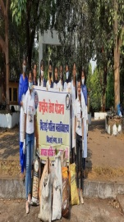
19 | Diya Making | 29/10/22 | NSS volunteer decorate diya then sell-out and after collected money they distributed sweet and deep in utakal basti | 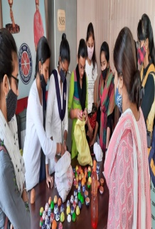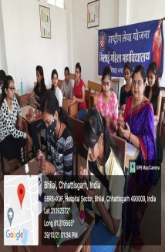
20 | Sardar Balav bhai Patal Jayanti | 31/10/22 | NSS volunteer take oath on rashtria ekta aur akhandata and take part in different desi spots | 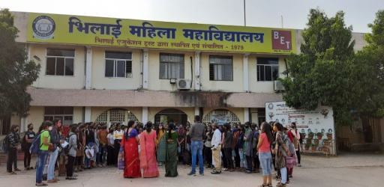
21 | Sambhidhan Diwas | 26/11/21 | On this day NSS officers organised quies comptation on our sambhidhan | 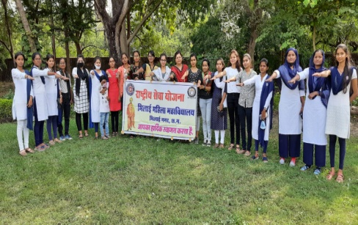
22 | Orientation Programme | 9/11/22 | 68 NSS volunteer attend this programme and answer the question related to NSS | 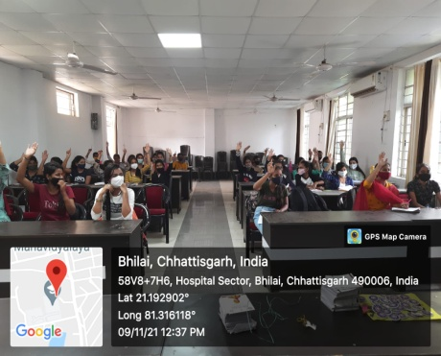
23 | AIDS awer program | 30/11/21 | 110 NSS volunteer and Red Ribbon Club association make Human Chain and awair public about aids | 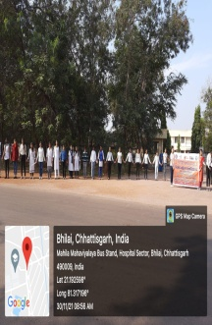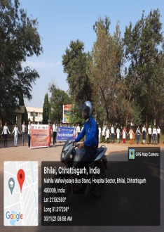
24 | Word AIDS Day | 1/12/21 | NSS Red Ribbon Club and Legal Services Authority make human chain on this event and give knowledge about low and rules | 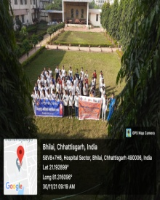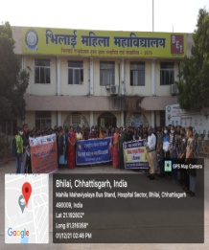
25 | Covid Tikakaran | 11/12/21 | NSS volunteer awear sector 8 public about covid vaccine | 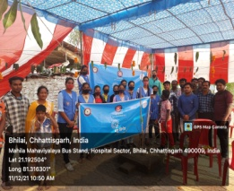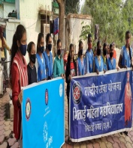
26 | Workshop on Yuva shakti | 13/12/21 | Unisef and NSS Collaboration Blue Bridge Phase II organise workshop and NSS volunteer NOMITA THAKUR participate in it | 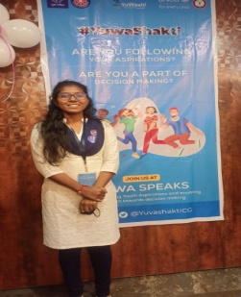
27 | Samajik Jagarukta For Hanoda Gram | 16/12/21 | 129 NSS volunteer Meeting For social programme organised in Hemchand Yadav University Godgram Hanoda | 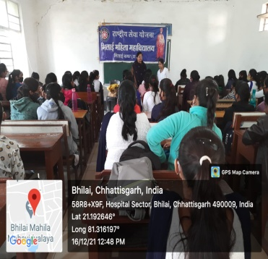
28 | Covid Tikakaran | 27/12/21 | 68 NSS volunteer going to Utakal Basti and awear public for Covid Tikakaran with the help of Reilly, slogan ,Door To Door meeting. | 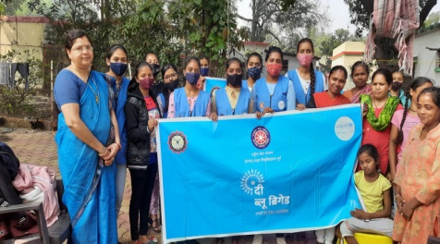
29 | VIVEKANAND JAYANTI | 12/01/22 | 100 Volunteer participate and light on the life of vivakanand .some sing patriotism song, poem etc. | 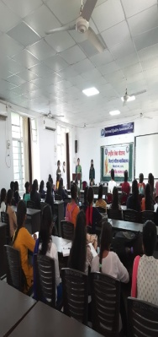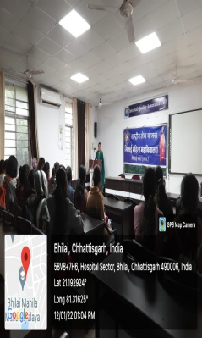
30 | PULSE POLIO | 27/02/22 | Public Health Department organised pulse polio camp in bhilai mahila mahavidyalaya in this camp 50 volunteer participate ,they go door to door and call the public about this camp. | 