Criteria -5
5.1.3 –

Experiential learning: Experimental learning conducted in the form of practicals as per the syllabus of the University

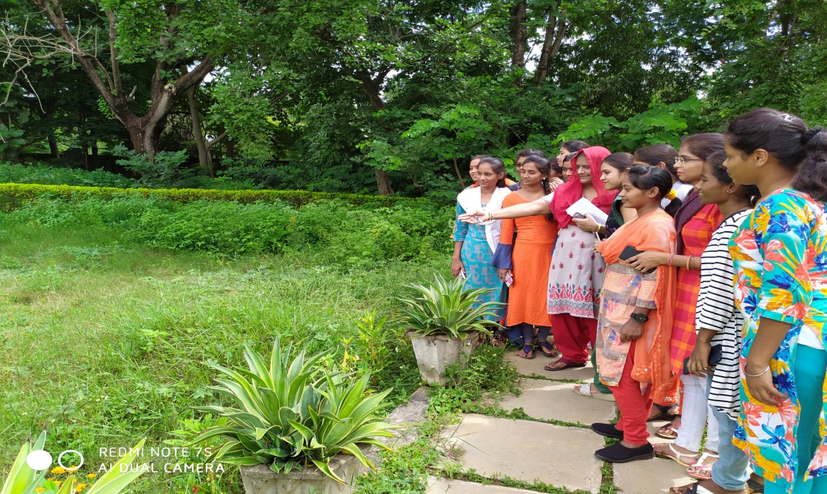 | 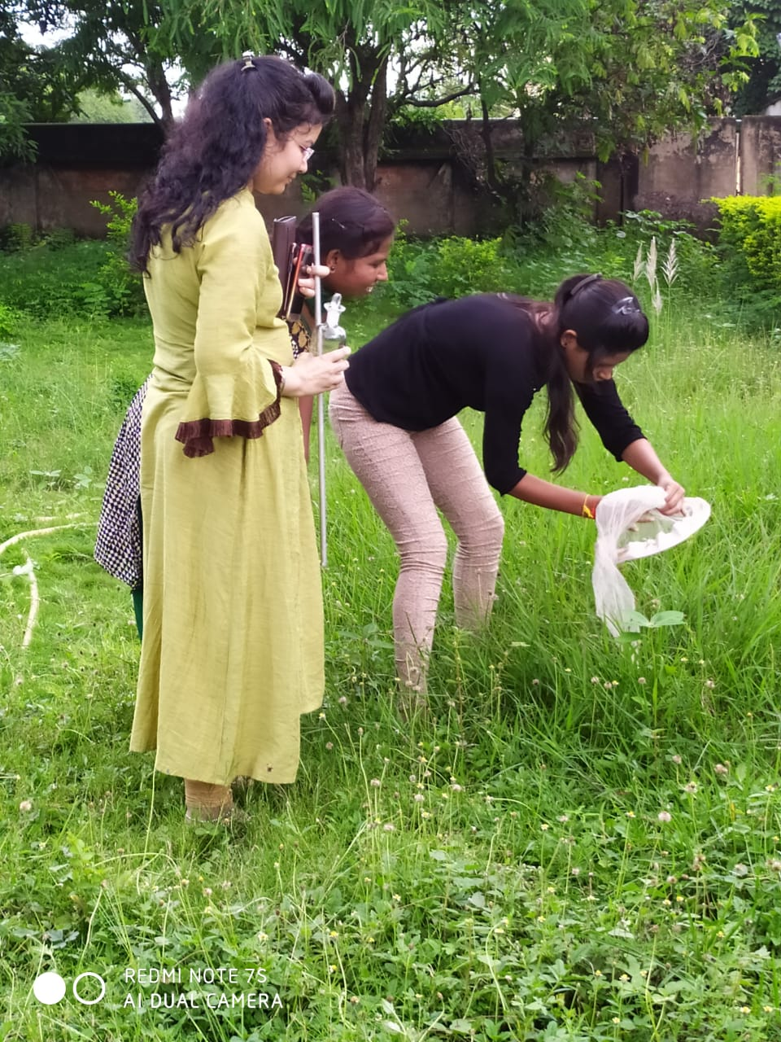
Zoological Excursion- Social Organization in Insect
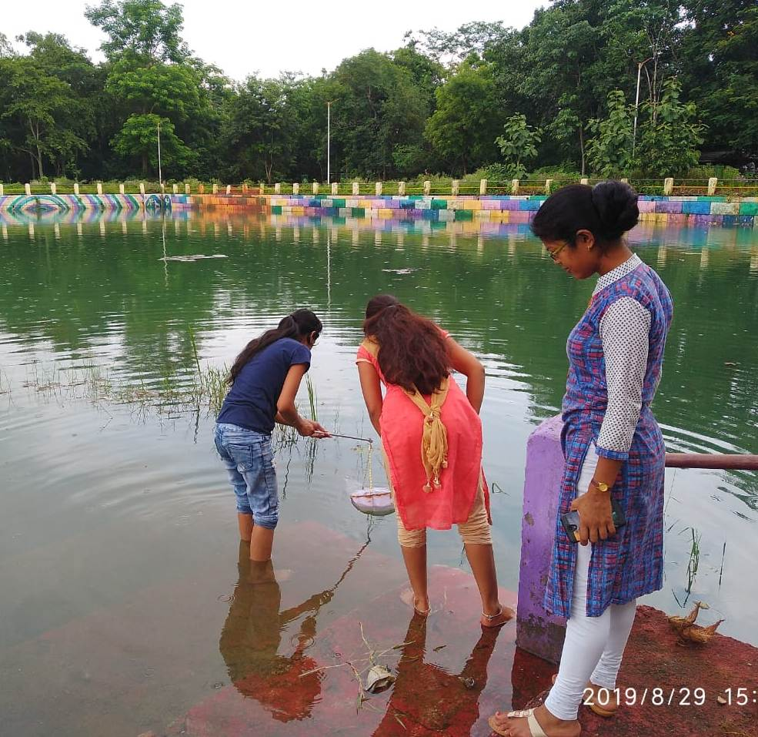 | 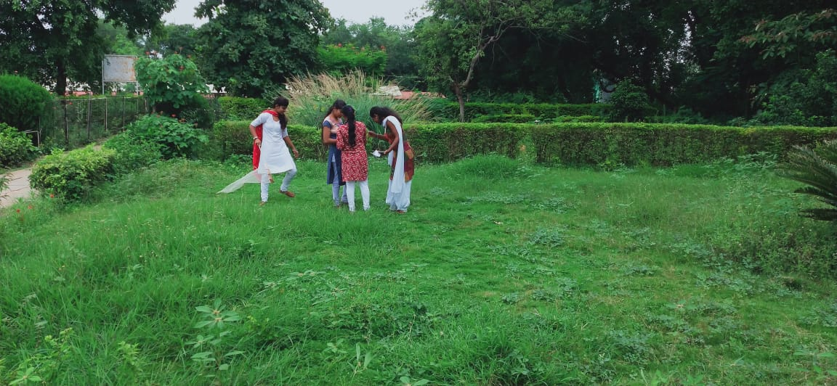
ExcursionStudy of Biodiversity of Pond Ecosystem | Study of Grassland ecosystem
 | 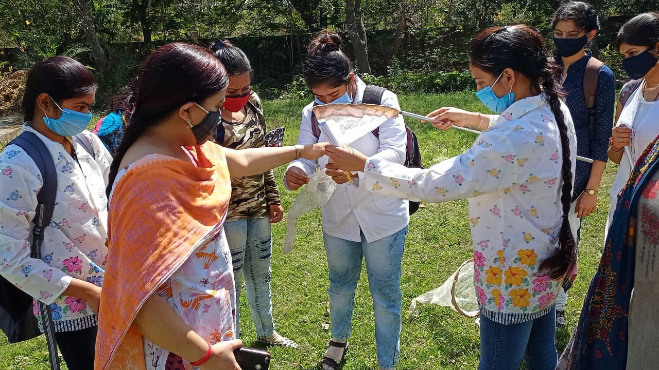
Study of Biodiversity

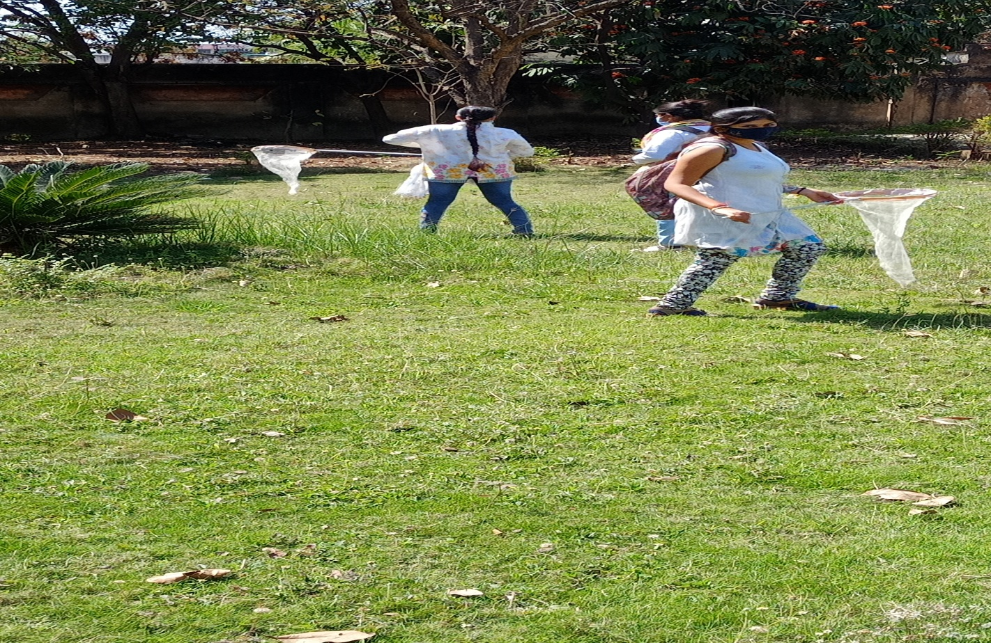 | 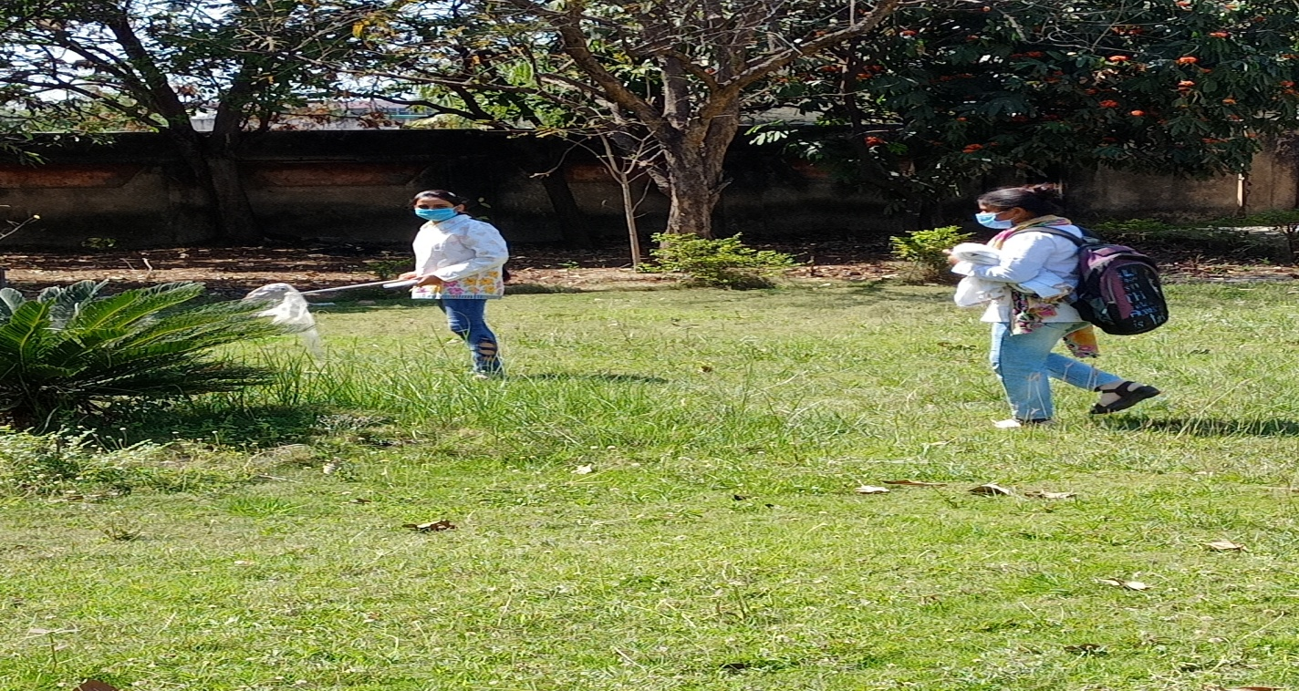
Study of Biodiversity of Grassland Ecosystem
Participative learning: Engage students in the class seminar, and field activities, Extempore, Museum learning, maintenance, clay modeling, etc

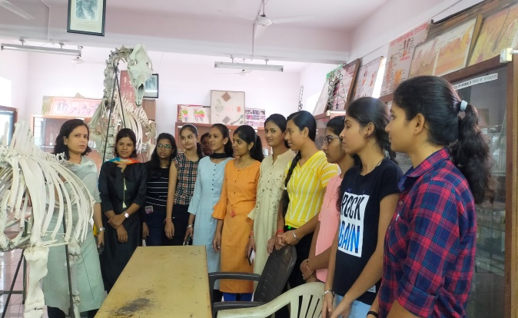 |  | 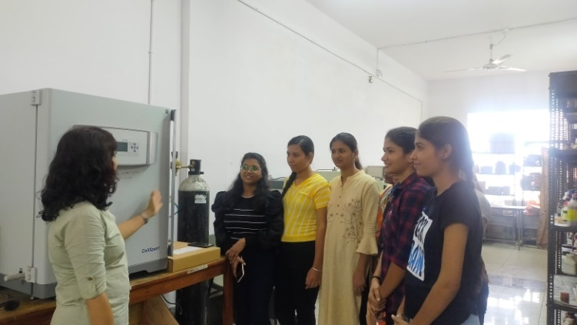
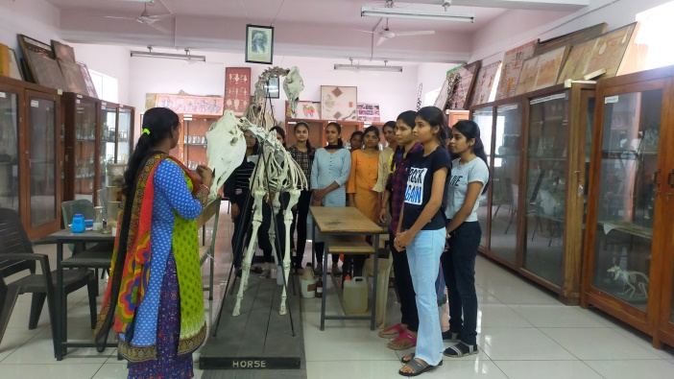 |  | 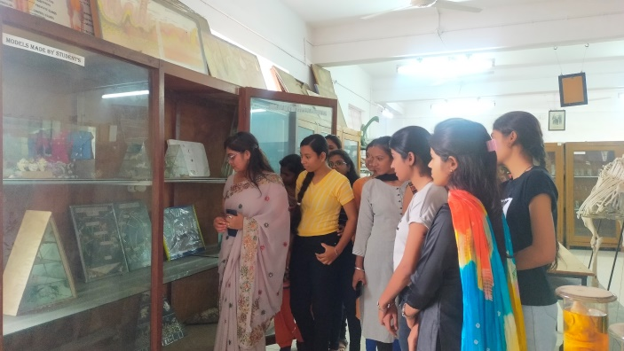
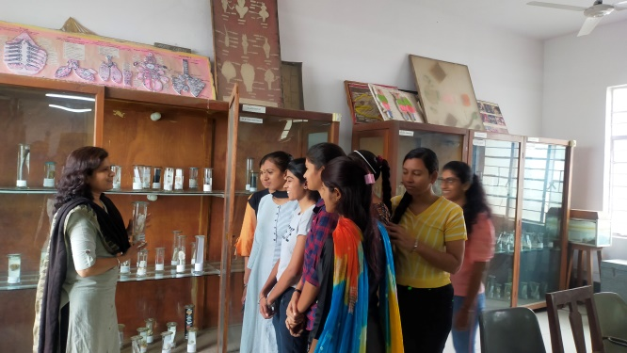 |  | 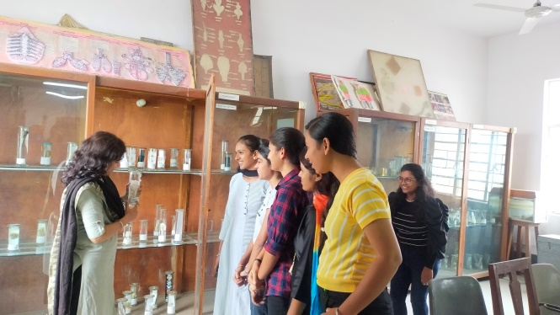
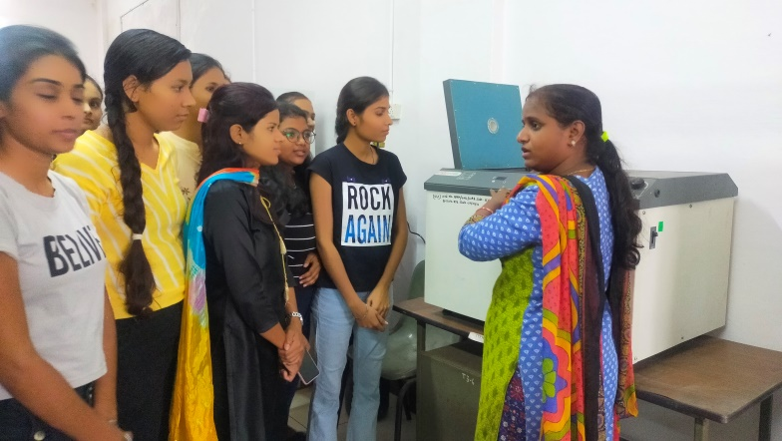 |  | 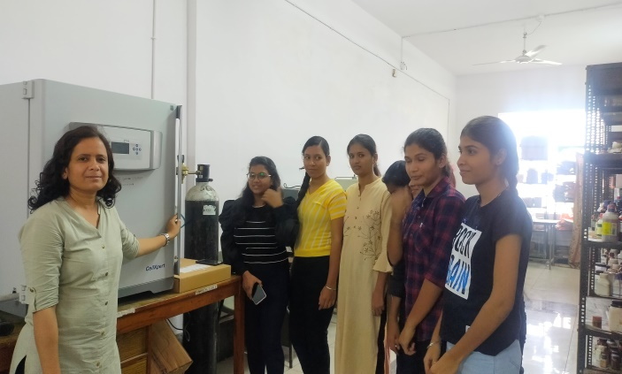
Museum Demonstration
Study of Grassland ecosystem Study of Pond ecosystem

- ICT Tools -

