Total corpus fund generated

2015-2016 | 55,16,272
2016-2017 | 79,63,926
2017-2018 | 24,49,426
2018-2019 | 1,29,97,688
2019-2020 | 3,51,46.062
2020-2021 | 3,41,50,278

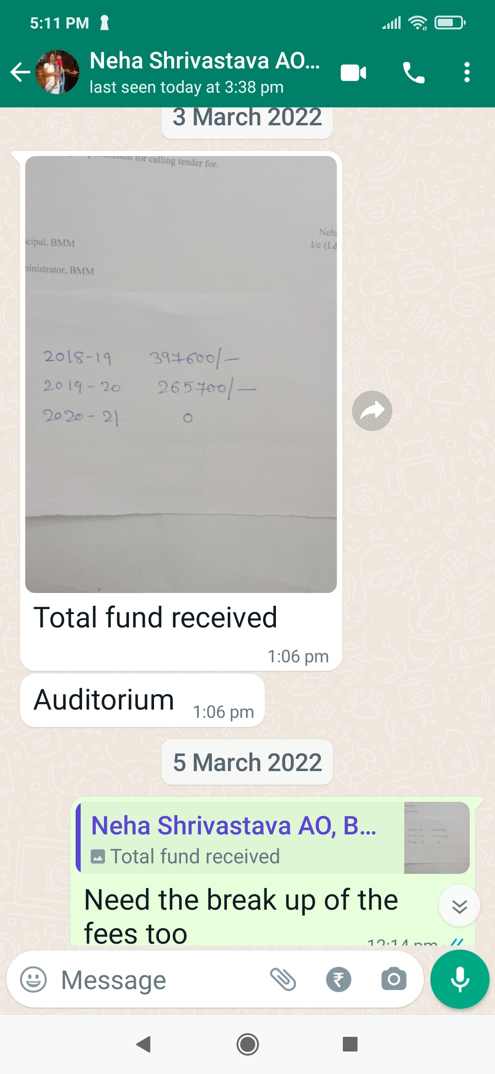
6.4.3.1. Fund Mobilization
S.No. | Year/Session | Title (Name of Activity/Program) | No. of Beneficiary | Proof
 | 2016-2017 | Tally Program  (Since 2018-2019 Tally Program has been included as an Add-on course) | 41 | 