Solid Waste –The solid waste collected during routine activities and daily basis like torn papers and files pens, pins extra are separated and put in garbage bins kept at various nooks and corners and piled waste is collected by the Nagar Nigam vans and further disposed on the garbage grounds. Waste from plants and dry leaves is also used for preparing organic compost, old newspaper is sold to a specific kabadi or raddiwala. Use of polythenes is discouraged and it is tried to make campus is made plastic free through posters & slogans display on the walls.
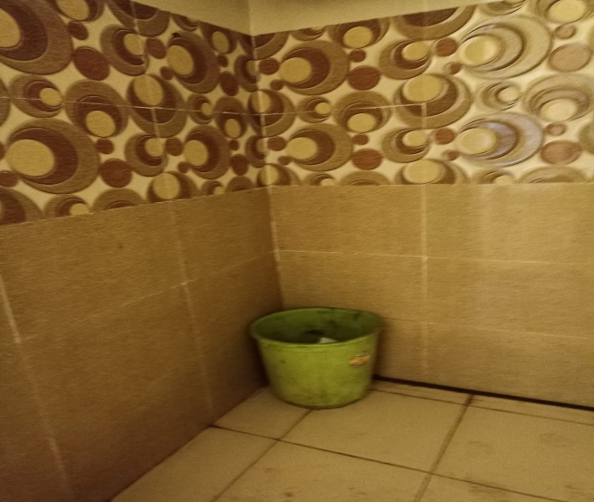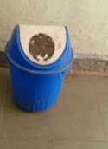
Liquid Waste – Is mainly given out by the hostel labs and canteen. The college has a covered sewerage system made of concrete pipes which lead to the main drainage system. The semiliquid waste from hostel and canteen is collected in waste pits.
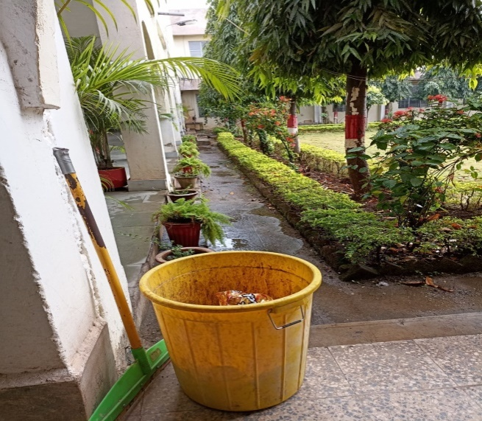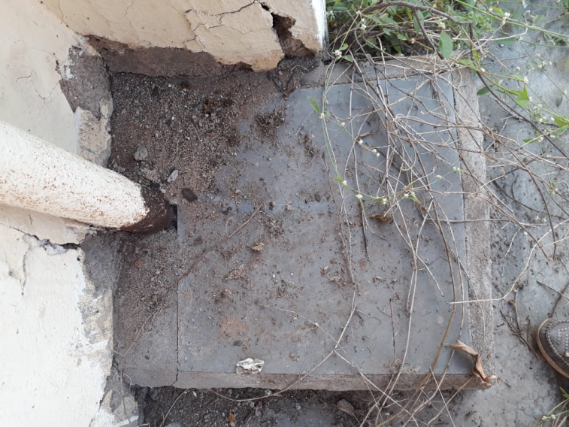

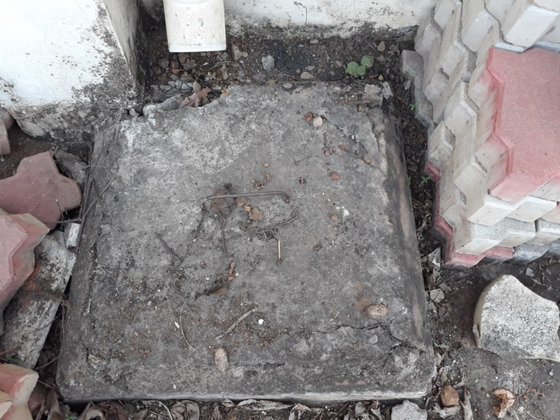

Bio-Medical Waste – In the form of sanitary napkins in girl’s toilets is disposed daily in the assigned pits.

E waste Management – The old and obsolete electronic products like computers and electrical or electronic items are written-off or repaired for further use at collected and marked locations for disposal.
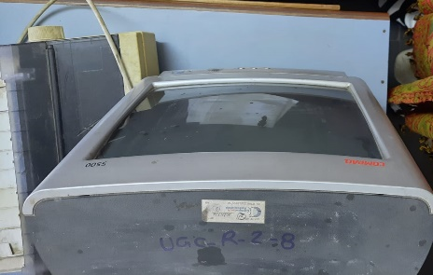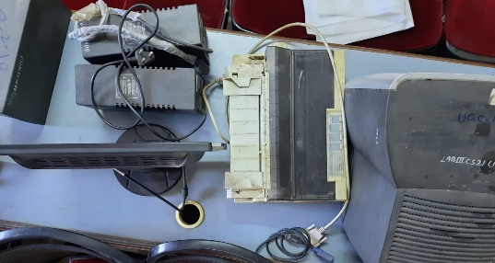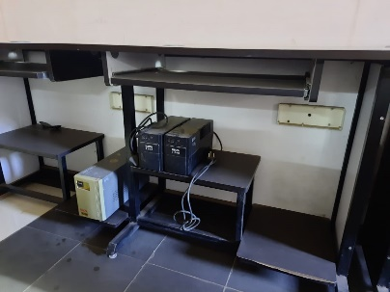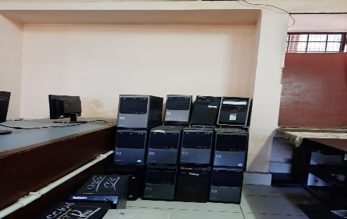

Hazardous chemical waste and radio-active waste – The activities and functions of the college do not generate any specific hazardous waste and hence there has not been any need for hazardous (chemical waste and radio-active waste) waste management.

