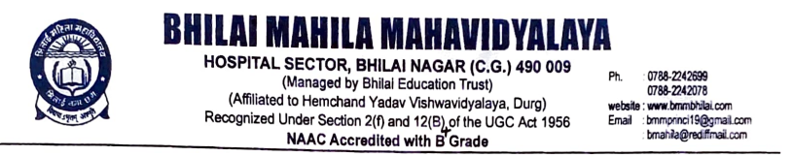

**Session 2023-24**

**Criterion -7**

**7.1. Institutional Values and Social responsibilities**

**7.1.3 -Environmental Consciousness and Sustainability**



***7.1.3. Waste Management steps including:***

* Solid waste management-yes
* Liquid waste management- Yes
* E-waste management- yes

|  |  |
| --- | --- |
| **Efforts** | **Evidence** |
| **Solid waste management** | C:\Users\Admin\Downloads\IMG-20221029-WA0008.jpg |
| **Liquid waste management** | WhatsApp Image 2024-12-30 at 10.36.16 AM.jpeg |
| **E-waste management** | WhatsApp Image 2024-12-30 at 10.35.16 AM.jpegWhatsApp Image 2024-12-30 at 10.35.14 AM.jpeg**Waste CD’s were converted into decorative wall hangings** |

