https://classroom.google.com/c/MTQ2MjY5ODkwNTAy?cjc=uiwzucs
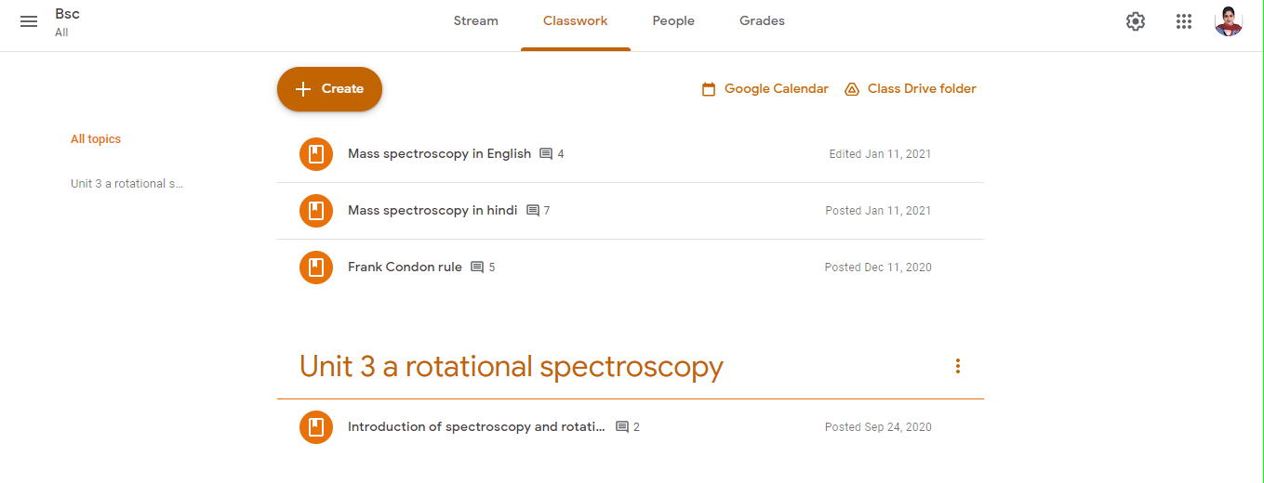

https://classroom.google.com/c/MTU1MDk1MDczMDEw?cjc=dd76ynj

